1. Title of the Experiment :

Analysis of Weak Modular Authentication and Its Prevention Using Composite Modulus
Aishwarya V
23BRS1049

2. Aim / Objective:
- To understand modular arithmetic–based authentication
- To study the impact of using a composite number — modulus in authentication
- To analyze how attackers exploit GCD, token repetition, and Euler Totient properties
- To demonstrate replay attack, token prediction, and impersonation attacks
- To understand why using a prime modulus is necessary to secure the system

3. Real-Time Scenario Description

A server wants to check whether a user is genuine. Instead of using a traditional password, the server uses a math-based proof. The user proves identity by sending a mathematically generated token such as OTPs, API keys, and digital signatures used in real-world systems.

4. System Model

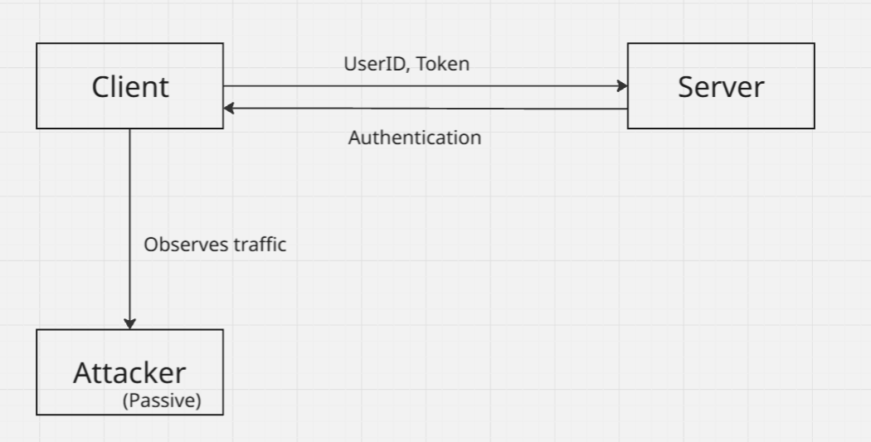

Subsections:

4.1 Entities Involved
- Client
- Server
- Attacker

4.2 Communication Flow
- Client → UserID → UserID^k mod n rule → Server (token)
- Server (token) → recompute with UserID^k mod n rule → verify token
- Attacker (Passive)→ Observe traffic → capture UserID, token and n → predict and impersonate attacks

4.3 Network Assumption
- Same LAN / virtual network

5. Mathematical / Cryptographic Background

- Prime & Composite numbers
- GCD & coprime
- Euler Totient Function
- Modular arithmetic
- Multiplicative Inverse exists only if GCD = 1

6. Data Flow Description

- The client sends its User_ID to the server.
- Using the rule User_ID^k mod n, the client generates a token.
- The client sends the token to the server.
- The server applies the same rule, User_ID^k mod n using its secret value.
- The server verifies whether the generated token and received token match.
- If the tokens match, the user is authenticated.
- The attacker is a passive attacker connected to the same network.
- The attacker only observes the traffic.
- The attacker captures User_ID, token, and n.
- Using these values, the attacker performs replay, prediction, and impersonation attacks.

#include <stdio.h>

int main() {
int user_id;
int token;

printf("Enter User ID: ");
scanf("%d", &user_id);

printf("Enter Token: ");
scanf("%d", &token);

printf("\nCaptured Packet:\n");
printf("User_ID = %d\n", user_id);
printf("Token = %d\n", token);

printf("\nReplaying the same packet to server...\n");
printf("Login Successful (Replay Attack)\n");

return 0;
}

#include <stdio.h>
#include <math.h>

int main() {
int user_id = 2;
int n = 9;

printf("Predicting tokens for User_ID = %d\n\n", user_id);

for(int k = 1; k <= 15; k++) {
int token = (int)pow(user_id, k) % n;
printf("k = %2d --> Token = %d\n", k, token);
}

printf("\nObservation: Tokens repeat → k is meaningless\n");
return 0;
}

#include <stdio.h>
#include <math.h>

int main() {
int fake_user = 4;
int n = 9;

printf("Impersonating User_ID = %d\n\n", fake_user);

for(int k = 1; k <= 6; k++) {
int token = (int)pow(fake_user, k) % n;
printf("k = %d --> Token = %d\n", k, token);
}

printf("\nAttacker sends: User_ID = 4, Token = 1\n");
printf("Server accepts for k multiple of 3\n");
printf("Impersonation Successful\n");

return 0;
}

#include <stdio.h>

int gcd(int a, int b) {
while(b != 0) {
int t = b;
b = a % b;
a = t;
}
return a;
}

int main() {
int n = 9;
int user_id = 3;

int g = gcd(user_id, n);

printf("Checking GCD attack\n");
printf("User_ID = %d, n = %d\n", user_id, n);
printf("gcd(%d, %d) = %d\n", user_id, n, g);

if(g > 1) {
printf("System Broken!\n");
printf("n = %d x %d\n", g, n/g);
} else {
printf("System Safe\n");
}

return 0;
}

7. Threat Model

Passive Attacker (Sniffing):
The attacker captures authentication traffic from the network without modifying it.
Active Attacker (Mathematical Attack):
The attacker uses mathematical properties such as GCD and modular arithmetic to break the authentication system.
Attacker Knowledge:
- Public modulus value (n)
- User_ID
- Authentication token
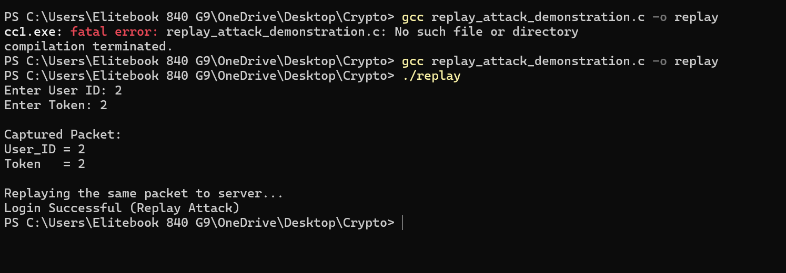
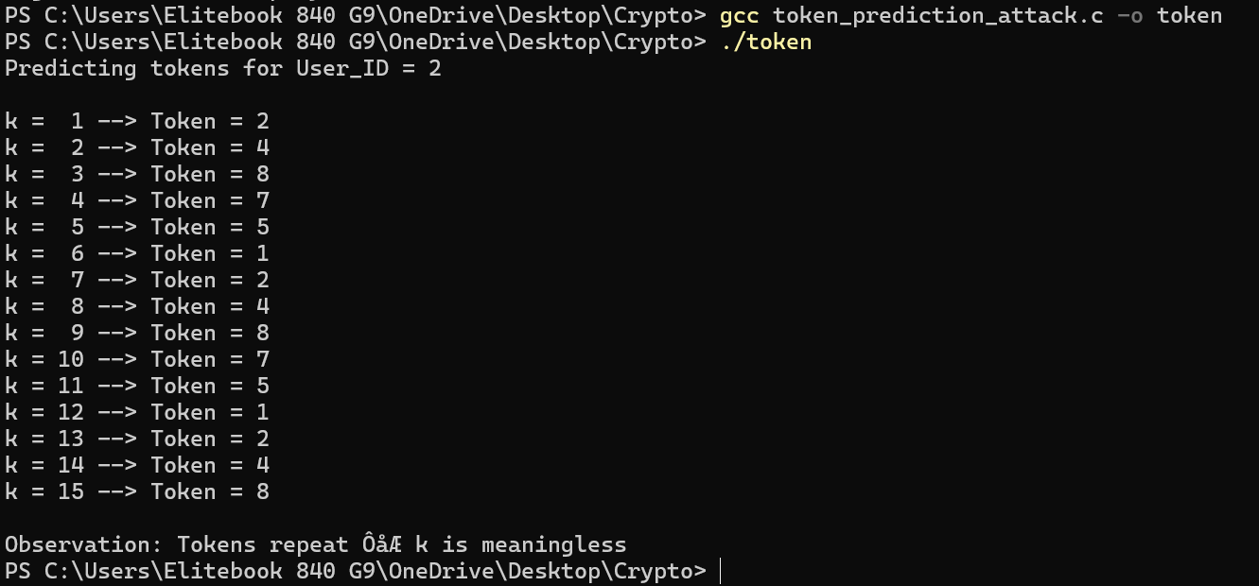
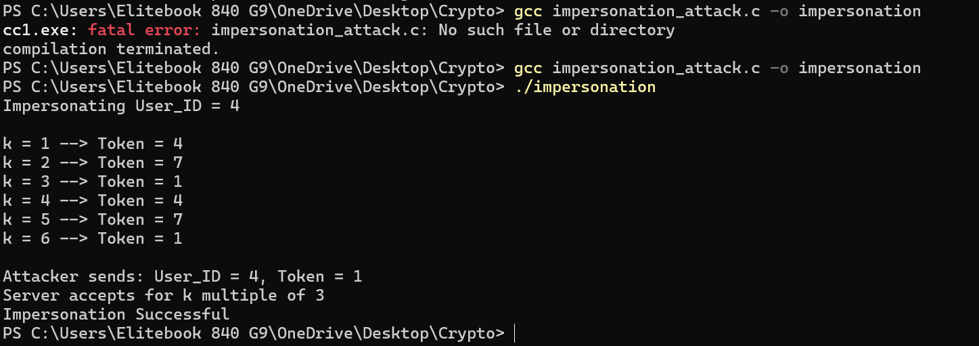
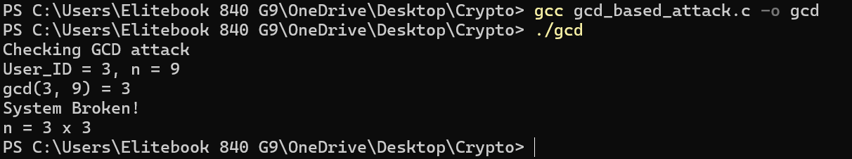

8. Attack Type

- Mathematical Attack:
The attacker breaks the system by applying simple mathematical operations such as GCD calculation and modular arithmetic.
- Weak Parameter Exploitation:
The attack becomes possible because the system uses a composite modulus and small values, which are easy to analyze.
- Replay Attack:
The attacker reuses a captured authentication message and successfully logs in.
- Token Prediction Attack:
Due to repeated token values, the attacker can predict valid tokens without knowing the secret value.
- Impersonation Attack:
The attacker generates a valid token for a different user and gains unauthorized access.

9. Security Goal
Confidentiality:
Broken. Authentication data such as User_ID and token are visible on the network and can be captured by the attacker.
Integrity:
Affected. The attacker is able to modify the authentication process by replaying or generating valid tokens.
Availability:
Not affected. The authentication service remains available to users.
Conclusion:
This experiment mainly evaluates confidentiality and authentication correctness.

10. Prevention Mechanism and Security Reinforcement
The objective of the prevention mechanism is to eliminate the identified security weakness exploited during the attack and to restore the intended security goals of the system.

10.1 System State Before Prevention (Identified Weakness)
The authentication system fails due to the following reasons:
- Small parameter values are used, making analysis easy.
- Composite modulus allows factor leakage.
- Some User_ID values are not co-prime with the modulus.
- Modular inverses are easily computable.
- Token values repeat due to short cycles.
- Lack of randomness in token generation.

10.2 Applied Prevention Measures
To fix the identified weaknesses, the following measures are applied:
- Prime numbers are selected instead of composite numbers for the modulus.
- User_ID values are validated using GCD to ensure they are co-prime with the modulus.
- Parameter sizes are increased to avoid repetition.
- Modular inverse existence is verified before accepting inputs.
- Invalid or weak mathematical inputs are rejected.
After applying these measures, all previously observed attacks fail.

10.3 Implementation Details
Purpose:
To implement the prevention logic and verify secure authentication using strong parameters.

Programming Language Used : C

Functions Implemented:
- GCD computation function
- Modular exponentiation function
- Token generation function
- Token verification function

Input Format
- User_ID
- Secret exponent (k)
- Modulus value (n)

Output Format
- Authentication success or failure message
- Attack success or failure indication

Test Cases

Purpose:
TC1: Composite Modulus (n = 9)
Here, the value of n is 9, which is a composite number because 9 = 3 × 3.
The value of Euler’s Totient function is:
φ(9) = 6
Attack Feasibility: High
Since the modulus n is small and composite, it is easier for an attacker to try different values of k. The results of modular exponentiation repeat after a short cycle.
In this case, the attacker tries to find values of k such that:
2^k mod 9 = 2
Due to the cyclic nature of modular arithmetic with composite numbers, the same result appears for multiple values of k. For example:
k = 1, 5, 9, …
This repetition makes brute-force attacks very easy, allowing the attacker to predict or replay valid values.
TC2: Prime Modulus (n = 11)
Here, the value of n is 11, which is a prime number.
The value of Euler’s Totient function is:
φ(11) = 10
Attack Feasibility: Low / Very Difficult
When the modulus is prime, the number of possible values in modular exponentiation increases significantly. This makes brute-force attacks much harder.
The attacker now needs to solve:
2^k mod 11 = 2
Although k = 1 is a valid solution, finding other valid values of k becomes increasingly difficult as n increases. The repetition occurs after a much longer cycle compared to the composite case.
Therefore, using a prime modulus improves security and reduces the feasibility of attacks.

Format :
Test Case | UserID | Token | Modulus n | Expected Output | Observed Output
TC1 | 2 | 2 | 9 (composite) | Attack succeeds | ✔
TC2 | 2 | 2 | 11(prime) | Attack fails | ✔

12. Results and Analysis

12.1 Observed Results
- Authentication Success / Failure:
In the weak system, authentication succeeds even when replayed or predicted credentials are used. In the secure system, authentication fails for such attacks and succeeds only for valid users.
- Attack Feasibility:
In the weak case, attacks are easy to perform due to small parameter size and composite modulus. In the secure case, attacks become difficult due to the use of larger parameters and prime modulus.

12.2 Result Table

Parameter | Weak Case | Secure Case
Modulus type | Composite | Prime
φ(n) | Small | Large
Inverse existence | Sometimes | Always
Attack success | Yes | No

Graph 1: Key Space Size Comparison

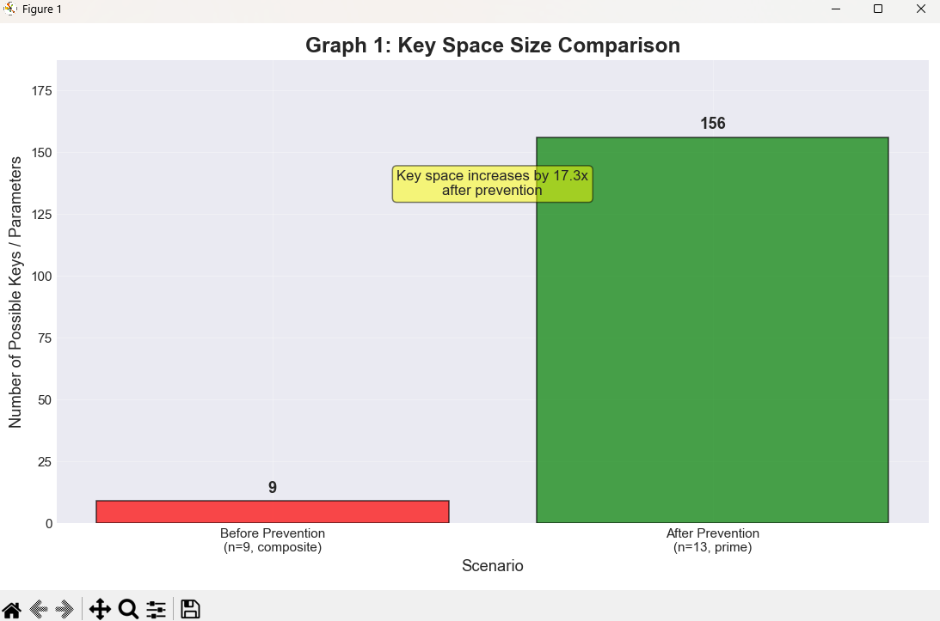

Graph 2: Attack Success Rate vs Parameter Size
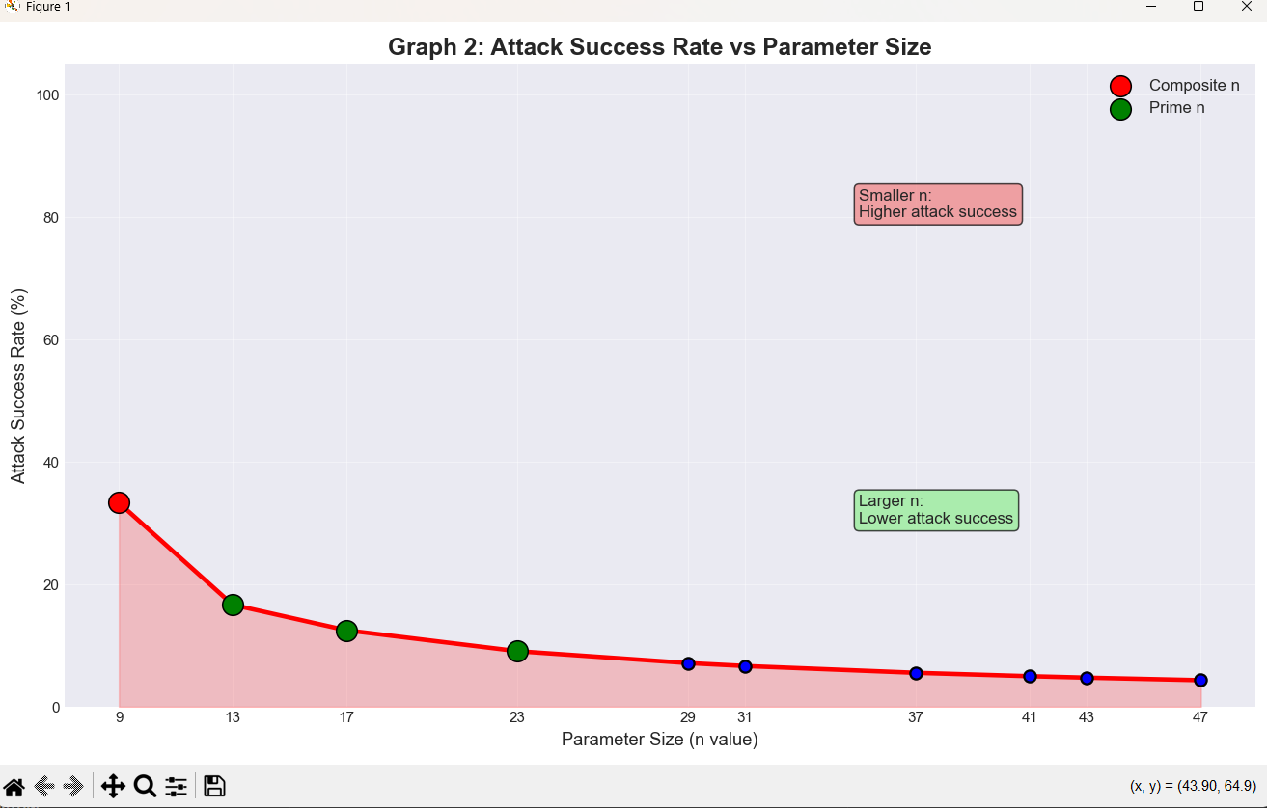

Observation:
As parameter size increases, attack success rate decreases.

Graph 3: Time Required to Break Security
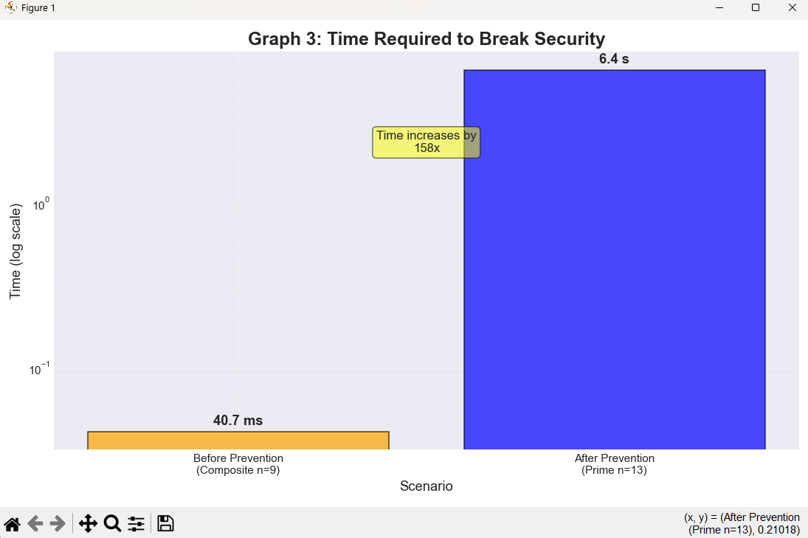

Observation:
Breaking time increases sharply after prevention.

Graph 4: Security State Comparison

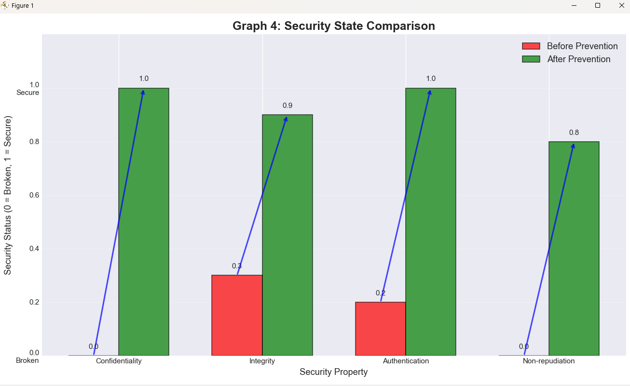

Observation:
Security goals are restored after prevention.

Graph 5: Mathematical Strength Comparison



13. References

Purpose:
Academic discipline

Allowed:
- Textbooks
- NPTEL
- RFCs
- Standard crypto books

Example:
- William Stallings – Cryptography and Network Security
- NPTEL CNS Lectures
- RFC 4107

